Diffie–Hellman key exchange

Platesnė sąvoka – Key Management
Diffie–Hellman key exchange (D–H)^{[nb 1]} is a specific method of exchanging cryptographic keys. It is one of the earliest practical examples of key exchange implemented within the field of cryptography. The Diffie–Hellman key exchange method allows two parties that have no prior knowledge of each other to jointly establish a shared secret key over an insecure communications channel. This key can then be used to encrypt subsequent communications using a symmetric key cipher.
The scheme was first published by Whitfield Diffie and Martin Hellman in 1976, although it had been separately invented a few years earlier within GCHQ, the British signals intelligence agency, by Malcolm J. Williamson but was kept classified. In 2002, Hellman suggested the algorithm be called Diffie–Hellman–Merkle key exchange in recognition of Ralph Merkle's contribution to the invention of public-key cryptography (Hellman, 2002).
Although Diffie–Hellman key agreement itself is an anonymous (non-authenticated) key-agreement protocol, it provides the basis for a variety of authenticated protocols, and is used to provide perfect forward secrecy in Transport Layer Security's ephemeral modes (referred to as EDH or DHE depending on the cipher suite).
The method was followed shortly afterwards by RSA, an implementation of public key cryptography using asymmetric algorithms.

The idea.

Diffie–Hellman establishes a shared secret that can be used for secret communications by exchanging data over a public network. The following diagram illustrates the general idea of the key exchange by using colours instead of a very large number. The key part of the process is that Alice and Bob exchange their secret colours in a mix only. Finally this generates an identical key that is mathematically difficult (impossible for modern supercomputers to do in a reasonable amount of time) to reverse for another party that might have been listening in on them. Alice and Bob now use this common secret to encrypt and decrypt their sent and received data. Note that the yellow paint is already agreed by Alice and Bob:
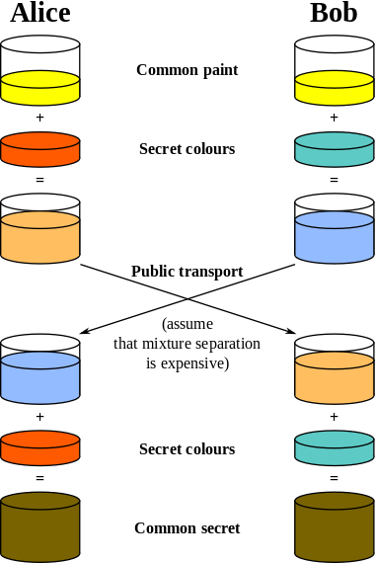

Here is an explanation which includes the encryption's mathematics:
The simplest, and original, implementation of the protocol uses the multiplicative group of integers modulo p, where p is prime and g is primitive root mod p. Here is an example of the protocol, with non-secret values in blue, and secret values in boldface red:
Alice |  |  |  | Bob
Secret | Public | Calculates | Sends | Calculates | Public | Secret
a | p, g |  | p,g |  |  | b
a | p, g, A | gª mod p = A | A |  | p, g | b
a | p, g, A |  | B | g^{b} mod p = B | p, g, A, B | b
a, s | p, g, A, B | Bª mod p = s |  | A^{b} mod p = s | p, g, A, B | b, s

- Alice and Bob agree to use a prime number p=23 and base g=5.
- Alice chooses a secret integer a=6, then sends Bob A = gª mod p
  - A = 5⁶ mod 23
  - A = 15,625 mod 23
  - A = 8
- Bob chooses a secret integer b=15, then sends Alice B = g^{b} mod p
  - B = 5¹⁵ mod 23
  - B = 30,517,578,125 mod 23
  - B = 19
- Alice computes s = B ª mod p
  - s = 19⁶ mod 23
  - s = 47,045,881 mod 23
  - s = 2
- Bob computes s = A ^{b} mod p
  - s = 8¹⁵ mod 23
  - s = 35,184,372,088,832 mod 23
  - s = 2
- Alice and Bob now share a secret: s = 2. This is because 6*15 is the same as 15*6. So somebody who had known both these private integers might also have calculated s as follows:
  - s = 5^{6*15} mod 23
  - s = 5^{15*6} mod 23
  - s = 5⁹⁰ mod 23
  - s = 807,793,566,946,316,088,741,610,050,849,573,099,185,363,389,551,639,556,884,765,625 mod 23
  - s = 2
Both Alice and Bob have arrived at the same value, because (gª)^{b} and (g^{b})ª are equal mod p. Note that only a, b and g^{ab} = g^{ba} mod p are kept secret. All the other values – p, g, gª mod p, and g^{b} mod p – are sent in the clear. Once Alice and Bob compute the shared secret they can use it as an encryption key, known only to them, for sending messages across the same open communications channel. Of course, much larger values of a, b, and p would be needed to make this example secure, since it is easy to try all the possible values of g^{ab} mod 23. There are only 23 possible integers as the result of mod 23. If p were a prime of at least 300 digits, and a and b were at least 100 digits long, then even the best algorithms known today could not find a given only g, p, g^{b} mod p and gª mod p, even using all of mankind's computing power. The problem is known as the discrete logarithm problem. Note that g need not be large at all, and in practice is usually either 2, 3 or 5.

------------------------------------------------------------------------
http://www.youtube.com/watch?v=dlS5_qfxAss Intro_1
http://www.youtube.com/watch?v=SFXYCT9-SeM Intro_2
http://www.youtube.com/watch?v=40i9ujVJ040
http://www.youtube.com/watch?v=8lpWVONYFBg Key management

